Africa-Americas Forum on China-2026
Speaker List

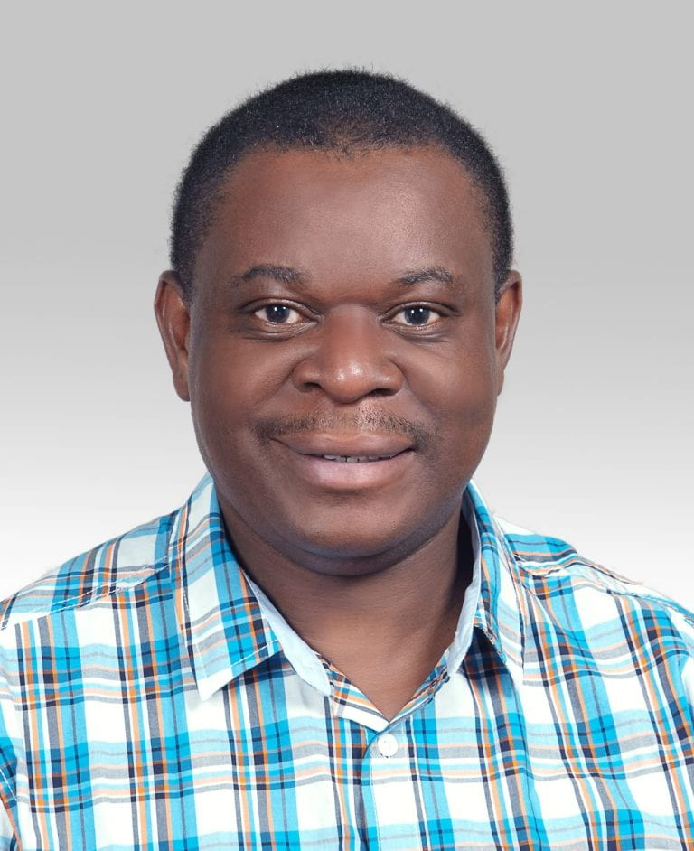

Bob Wekesa, University of Witwatersand

Bob Wekesa is the Director of the African Centre for the Study of the United States at the University of the Witwatersrand (Wits), South Africa which he helped establish along with others in March 2018. He is secretary to the U.S. Business in Africa Awards and interim chairman of the African Centres for the Study of the U.S. which brings together scholars from eleven African universities. He is secretary to the Governing Board of the U.S. Business in Africa Awards (USBAA), an industry-academia-policy partnership inaugurated in February 2020. Since 2015, Wekesa has been a senior lecturer at the Wits Centre for Journalism where he teaches and supervises international communications. He holds bachelor’s degree from the University of Nairobi and master’s and doctoral degrees from the Communication University of China. His area of teaching, research and public engagement is international communication, the intersection of media and international affairs. His publication record includes conceptualization and editorship of seminal special issue on “digital diplomacy in Africa” published by the South African Journal of International Affairs (2021); a book chapter on African public diplomacy in the respected Routledge Handbook of Public Diplomacy (2020) and editorship of a first-of-kind volume entitled “Africa’s Policy Towards the U.S.: The Biden Era” (2021) – a sequel is the works. His latest editorship, “China versus the U.S.: The Battle for Digital Supremacy in Africa” came out in July 2022. His single authored book, “China’s Footprint in East Africa: Optimism, Pessimism, Pragmatism” is due for publication by Palgrave Macmillan (expected late 2022). He has been published extensively on Africa-China and Africa-U.S. relations in peer reviewed journals, books, newspapers, and blogs. Among other projects he is currently leading is “U.S.-Africa Cities” conference and publication project. He sits on the boards of various journals and academic networks.

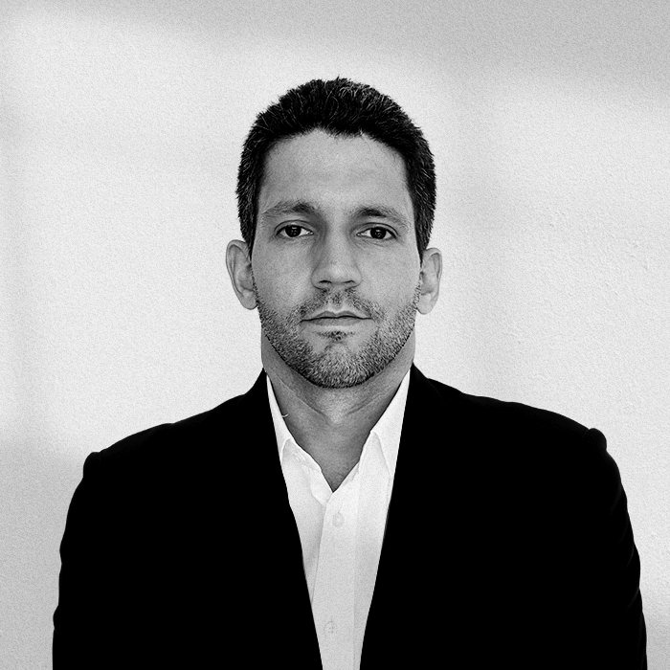
Parsifal D’Sola, Andres Bello Foundation
Founder and Executive Director of the Andrés Bello Foundation – China Latin America Research Center. He is a foreign policy analyst specializing in Sino-Latin American relations with a focus on Venezuela. Parsifal is a non-resident senior fellow at the Atlantic Council’s Global China Hub. In 2019, he served as a foreign policy advisor on China for the interim government of Venezuela’s Ministry of Foreign Affairs. Parsifal lived in Beijing from 2008 to 2016, where he worked as a communications manager and researcher for the news agency China Files. He holds a degree in Telecommunications Engineering from the Andrés Bello Catholic University (Venezuela), a Master’s in East Asian Studies from Columbia University (USA), a Master’s in International Politics from the School of Oriental and African Studies (SOAS), University of London (UK), and a diploma in advanced language studies from the Beijing Language and Culture University (China).

Margaret Myers, Johns Hopkins SAIS

Margaret Myers is the director of the Asia & Latin America Program at the Inter-American Dialogue. She publishes extensively on Chinese leadership dynamics, international capital flows, Chinese agricultural policy, and Asia-Latin America relations, among other topics. The Political Economy of China-Latin America Relations and The Changing Currents of Trans-Pacific Integration: China, the TPP, and Beyond, her co-edited volumes with Dr. Carol Wise and Dr. Adrian Hearn, respectively, were published in 2016. Myers has testified before the House Committee on Foreign Affairs on the China-Latin America relationship and is regularly featured in major domestic and international media, including the Economist, Financial Times, New York Times, Wall Street Journal, El Comercio, Folha de São Paulo, CNN en Español, CCTV, and Voice of America. In 2018, she was identified by Global Americans as part of the “new generation of public intellectuals.”

Before the Inter-American Dialogue, Myers worked as a Latin America analyst and China analyst for the US Department of Defense, during which time she was deployed with the US Navy in support of Partnership of the Americas. Myers also worked as a senior China analyst for Science Applications International Corporation, a consultant for the Inter-American Development Bank, a faculty member at Georgetown University and the George Washington University, and for Fauquier County Schools, where she developed the county’s first Mandarin language program.

Myers received her bachelor’s degree from the University of Virginia and conducted her graduate work at The George Washington University, Zhejiang University of Technology, and the Johns Hopkins University/Nanjing University Center for Chinese-American Studies. Myers was a Council on Foreign Relations term member. She was also the recipient of a Freeman fellowship for China studies and a Fulbright Specialist grant to research China-Colombia relations in Bogotá.

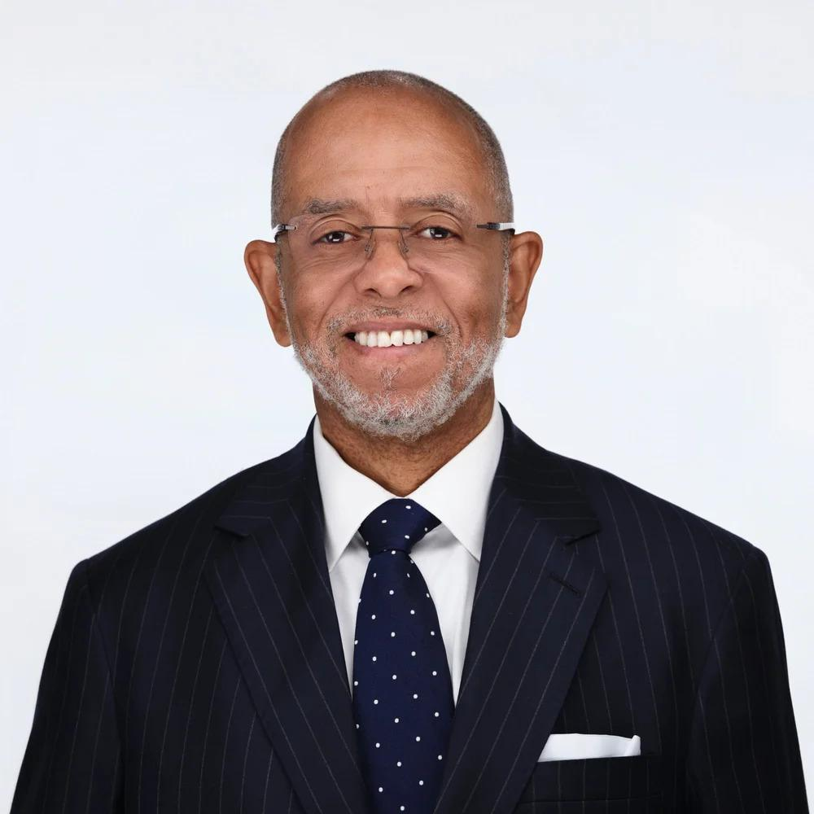
Ricardo Laremont, Binghamton University
Ricardo René Larémont, J.D., Ph.D., is a political scientist, sociologist, and international consultant whose work focuses on political Islam, Islamic law, comparative governance, conflict resolution, and civil–military relations. Over nearly three decades of research, teaching, and advisory engagement across North Africa, West Africa, the Sahel, and the wider Muslim world, his career has been shaped by a sustained effort to understand how religion, law, and political authority interact in historically and institutionally specific contexts.

Larémont is Professor Emeritus of Political Science and Sociology at SUNY Binghamton, where he pursued a career that combined scholarship, undergraduate and graduate teaching, and academic leadership. He received his Ph.D. in Political Science from Yale University and his J.D. from New York University School of Law, a combination that has informed his long-standing interest in legal systems, constitutional authority, and the political uses of law in both democratic and non-democratic settings.

His scholarly work examines Islamist movements, Islamic legal traditions, and state–society relations in Africa and the Middle East through a comparative and historically grounded lens. He is the author of the forthcoming textbook Political Islam: Movements, Ideologies, and Governance in Comparative Perspective (Routledge, January 2026), which offers a systematic comparative analysis of Islamist ideas, organizational forms, and governing practices across the Muslim world. His earlier books include Islam and the Politics of Resistance in Algeria; Islamic Law and Politics in Northern Nigeria; Revolution, Revolt, and Reform in North Africa; Borders, Nationalism, and the African State; and The Causes of War and the Consequences of Peacekeeping in Africa. His articles have appeared in journals such as The Journal of the Middle East and Africa, The Journal of North African Studies, and Stability: International Journal of Security & Development.

In recent work, Larémont has turned attention to Moroccan foreign policy, developing an International Relations framework he terms “sovereignty entrepreneurship.” This body of research analyzes how Morocco has converted contested sovereignty over Western Sahara into diplomatic capital and regional influence across the Maghreb, the Sahel, and Francophone Africa. The project contributes to broader debates on regional statecraft, security cooperation, economic diplomacy, and the management of great-power relations by middle powers.

Alongside his academic work, Larémont has served as an advisor and consultant to international and governmental institutions, including the United Nations, the African Union, the European Commission, and the U.S. Departments of State and Defense. His advisory work has focused on governance reform, mediation, security-sector transformation, and political transitions in fragile and conflict-affected states, with an emphasis on empirically grounded and institutionally realistic approaches to peacebuilding and reform.

Trevor Lwere, Development Reimagined
Trevor Lwere is a Research and Coordination analyst at Development Reimagined with a background in Economics and Global Affairs. His interests include geopolitics, geoeconomics, and economic development. He holds a Masters’ degree in Global Affairs from Tsinghua University and a BA Economics from the University of Notre Dame.
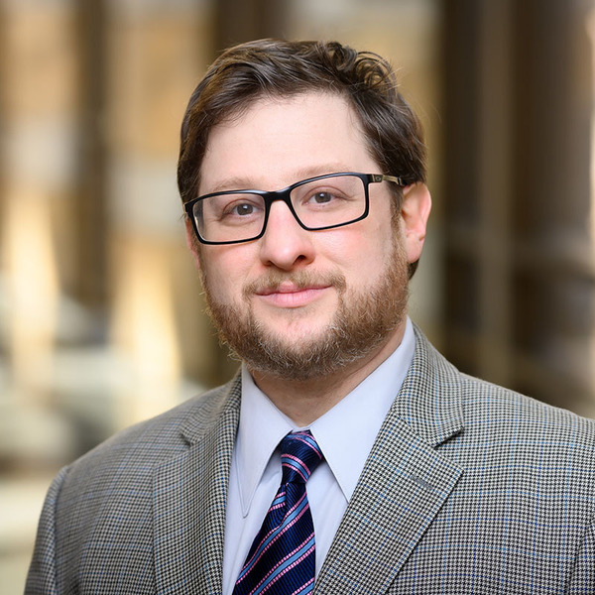
Joshua Eisenmann, Notre Dame
Joshua Eisenman is a Professor of Politics at Keough School of Global Affairs at the University of Notre Dame, and Senior Fellow for China Studies at the American Foreign Policy Council. His academic research has appeared in journals such as World Development, Third World Quarterly, and the Journal of International Development. He holds a PhD in Political Science from University of California, Los Angeles (UCLA).

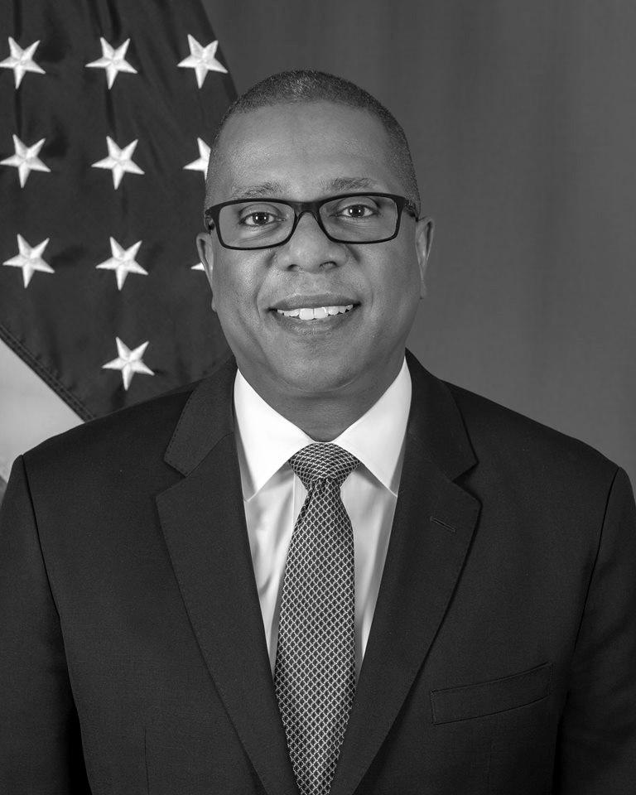
AMB Brian Nichols (Johns Hopkins, SAIS)
Ambassador Brian A. Nichols brings more than thirty-five years of leadership in international relations, crisis management, and economic development across Latin America, Africa, and Asia. As assistant secretary of state for Western Hemisphere affairs, he shaped U.S. policy across the region, overseeing substantial foreign assistance and operational budgets while advancing initiatives to promote trade, sustainable development, and democratic governance.
Ambassador Nichols currently serves on the boards of First Quantum Minerals, a global mining company, and the Pan American Development Foundation, an OAS-affiliated nonprofit focused on human development in Latin America and the Caribbean.
Previously, he served as U.S. ambassador to Zimbabwe and Peru, as well as in multiple senior diplomatic roles in Washington and abroad. He is widely recognized for championing economic growth, forging strategic public-private partnerships, and strengthening legal and regulatory frameworks to support international investment.
Ambassador Nichols holds a B.A. in political science from Tufts University and has received numerous honors for his distinguished service to U.S. foreign policy.


Juliana Jauregui (FLACSO Argentina)
Juliana González Jáuregui holds a PhD in Social Sciences from FLACSO Argentina; a Master's degree in International Relations and Negotiations from FLACSO Argentina and the University of San Andrés; and a Bachelor's degree in International Relations. She is a researcher in the International Relations Department at FLACSO Argentina and an assistant researcher at CONICET, within the framework of the Program for Strengthening Research and Cooperation with China/Asia in R&D&I. At FLACSO Argentina's International Relations Department, she coordinates the Chair of China Studies. She teaches at the postgraduate level at UCA, FLACSO, and other national and regional institutions. She was the only Latin American doctoral researcher to receive a scholarship from the European GRE:EN GEM program in conjunction with Fudan University in Shanghai (2012). She conducted postgraduate research stays at the Pontifical Catholic University of Chile (2014) and Brown University (2018). In 2018, she participated as the only Latin American expert awarded a scholarship by the China Center for Contemporary World Studies to receive training on the Belt and Road Initiative in major Chinese cities. In 2021, she was selected and awarded a scholarship for a postdoctoral research stay at the Institute of Latin American Studies at Columbia University. She has been invited as an expert to participate in international conferences on Latin America and China, including the Shanghai Forum, the Latin American Studies Association/Asia, and the International Studies Association. She is the representative of FLACSO/Argentina in the Fudan-Latin America University Consortium (FLAUC).

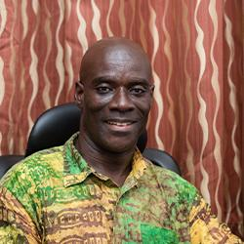
Richard Asante, University of Ghana
Richard Asante is a Ghanaian academic at the University of Ghana whose work sits at the intersection of development, governance, and social transformation in Africa. His scholarship is interdisciplinary in nature, engaging questions of political economy, institutions, and public policy, with a strong focus on how historical legacies and contemporary governance choices shape development outcomes in Ghana and across the continent. He is widely recognized for bringing empirical rigor and local context to debates that are often dominated by external perspectives on African development.
Beyond his research, Asante is an engaged educator and public intellectual, committed to mentoring students and contributing to policy-relevant conversations at the national, regional, and international levels. Through teaching, collaborative research, and partnerships with policymakers and civil society, he works to bridge the gap between academic analysis and real-world impact. His work reflects a broader commitment to strengthening African scholarship and ensuring that African voices and experiences are central to discussions about governance, development, and the future of the Global South.

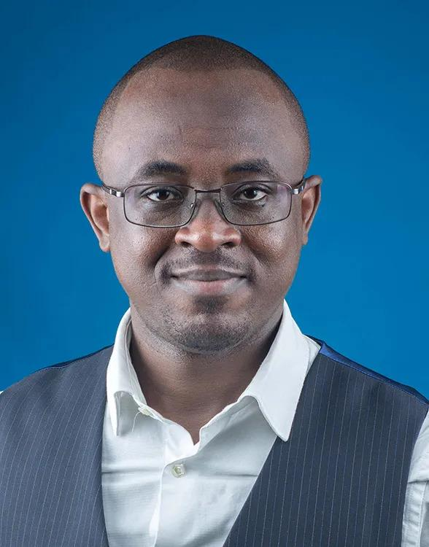
Christian Geraud Neema (China-Global South Project)
C. Géraud Neema Byamungu is an analyst and observer of China-Africa relations who graduated from Renmin University of China and has a master’s degree in International Development from the International University of Japan. In addition to his role at CGSP, Géraud is also a non-resident scholar in the Africa program at the Carnegie Endowment for International Peace in Washington, D.C. Previously, he worked as a project manager for a small Congolese mining company in DRC and later as a consultant on good governance and policy advocacy for the “Centre d’Etudes pour l’Action Social.”

Tatiana Carayannis, Institute for Advanced Study, Princeton University
A leading scholar of international organizations, global governance, and violent conflict in Central Africa, Tatiana is currently working on the geopolitics of AI and critical minerals supply chains. Previously, she served as program director at the Social Science Research Council and has had visiting appointments at LSE and NYU.
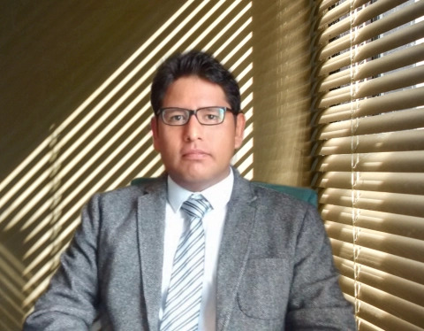
Cesar Gamboa (Derecho Ambiente y Recursos Naturales)
César is a lawyer and PhD in Law and Political Science from the Universidad Nacional Mayor de San Marcos. Master's in Democracy and Good Governance from the University of Salamanca. Professor of continuous teaching and researcher at the GEAS Environment and Society Studies Group of the Institute of Nature, Tierra y Energía INTE PUCP. Currently, he is the Executive Director of the Peruvian organization Derecho Ambiente y Recursos Naturales (DAR), whose priority aim is to promote the sustainable development of the Amazon. Since 2016, he has been a member of the EITI International Board (2016-2023). He is a member of the External Consultative Group of the Independent Consultation and Investigation Mechanism of the Inter-American Development Bank MICI BID and of the Board of Directors of PROFONANPE.

Asma Belem (Howard University)
Dr. Asma Amina Belem is a postdoctoral fellow with the Africa-China Initiative at Georgetown University and is in residency at Howard University this semester. She researches the political economy of Chinese engagements in Africa, particularly focusing on development assistance for health and environmental governance. Dr. Belem earned her PhD in Development Studies from National Cheng-Chi Universityin Taiwan. She also holds a master's degree in Applied Economics and Social Development from the same institution and a bachelor's degree in Economics from Université Thomas Sankara (formerly Université Ouaga II) in her native Burkina Faso.
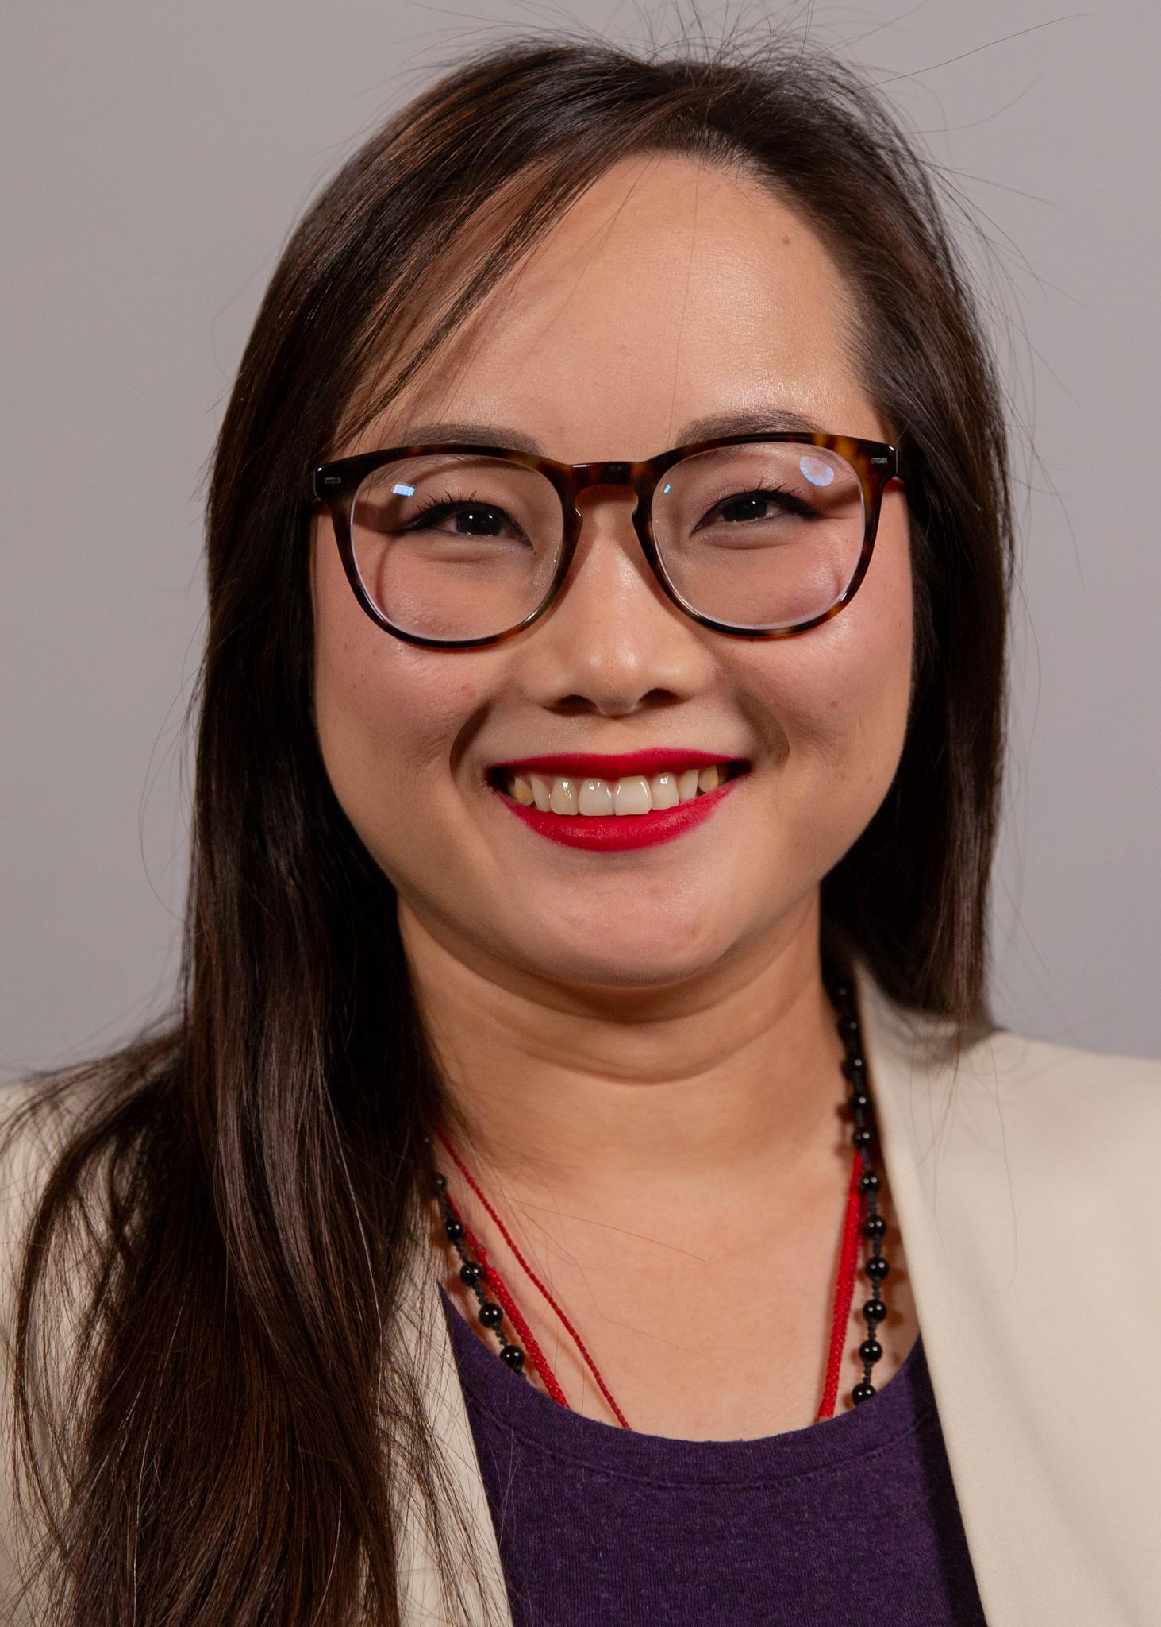
Victoria Chonn Ching
Victoria Chonn-Ching is a nonresident fellow with the Atlantic Council’s Adrienne Arsht Latin America Center, where she supports the Center’s China-Latin America work. Since 2021, she has been a postdoctoral scholar and teaching fellow in the Department of Political Science and International Relations at the University of Southern California.
She has worked as a researcher for the Commercial Service Office at the US embassy in Lima, Peru, where she conducted market research in the extractive and telecommunications industries. She was also part of the team that supported the establishment of Peru’s first center focused on the study of China and Peru-China relations at Universidad del Pacífico (UP) in Lima, Peru. There, she worked as the director’s assistant in the now Centro de Estudios sobre China y Asia-Pacífico and as a researcher at the Centro de Investigación.
Chonn-Ching has published extensively in academic and policy outlets about the China-Latin America relationship. Her works include “A Comparative View of Chinese Relations with Peru” in China, Latin America, and the Global Economy (2023), “The Complex Dance Around China’s Overseas Projects” (2023) with Alvin Camba, and “Conceptualizing China-Latin America Relations in the Twenty-First Century: The Boom, the Bust, and the Aftermath” (2018) with Carol Wise.
Chonn-Ching holds a doctorate degree in political science and international relations, as well as a master’s degree in economics from the University of Southern California. She also obtained a master’s degree in Chinese studies and a bachelor’s degree in political science and Asian studies, both from the University of Michigan, Ann Arbor. She speaks Spanish and Mandarin Chinese.
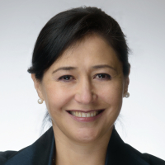
Dr. Liliana Diaz, Johns Hopkins SAIS
Dr. Liliana Diaz is an internationally renowned expert in energy and climate economics, bringing over 15 years of strategic consulting experience at the intersection of public policy, energy markets, and global sustainability. A distinguished advisor to companies, investors, and governments, she specializes in developing innovative policy and economic frameworks and actionable solutions for navigating the complex transition to a zero-carbon economy.
Dr. Diaz's expertise spans a comprehensive range of energy sectors, including renewable energy, emerging clean technologies, oil and gas, power generation, and energy efficiency. Her innovative approach combines deep technical knowledge with sophisticated economic analysis, enabling her to provide actionable solutions for addressing climate change and developing sustainable energy strategies.
With senior leadership roles at prestigious firms like McKinsey and Company–Vivid Economics, APCO Worldwide, FTI Consulting, Berkeley Research Group, and Navigant Consulting (currently Guidehouse), she has cultivated a robust international portfolio of projects encompassing economic and financial analysis, public policy design and formulation, regulatory assessments, strategic investments, and climate policy and carbon credit evaluations across North America, Latin America, Europe, Asia, and the Middle East.
As a thought leader in decarbonization strategies and environmental policy, Liliana brings unparalleled insight into the intricate relationships between energy economics, technological innovation, and global climate challenges.
Dr. Diaz holds a Ph.D. in International Economics and Energy Policy (with honors) and MA in International Economics (with distinction) from The Paul H. Nitze School of Advanced International Studies (SAIS) at Johns Hopkins University and a BA in Finance and International Affairs from Universidad Externado in Colombia.
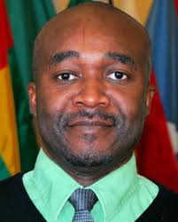
Paul Nantulya (NDU)
As a research associate at the Africa Center, Paul Nantulya researches and prepares written analysis on contemporary Africa security issues. His areas of expertise include Chinese foreign policy, China/Africa relations, African partnerships with Southeast Asian countries, mediation and peace processes, the Great Lakes region, and East and Southern Africa.
Prior to joining the Africa Center, Mr. Nantulya served as a regional technical advisor on South Sudan for Catholic Relief Services (CRS) from 2009 to 2011, where he supported crisis mitigation for the Government of South Sudan including writing policy analyses for the Ministry of Peace and Comprehensive Peace Agreement Implementation. In this role he worked closely with South Sudan’s external partners, particularly Japan’s International Cooperation Agency, on conflict prevention.
In 2005-09, Mr. Nantulya was CRS/Sudan’s governance manager in Juba. In this capacity he coordinated technical assistance for the Office of the President on establishing functional systems of state and local government. Mr. Nantulya previously worked for the South Africa-based Africa Center for the Constructive Resolution of Disputes (ACCORD), coordinating ACCORD’s participation in the Tokyo International Conference on African Development, the preeminent forum for Japan/Africa relations. He also worked on civilian and military peacekeeping in the Southern African Development Community. Additionally, he was part of the ACCORD team that worked with President Nelson Mandela on the Arusha Peace Process on Burundi (1999-2001), President Thabo Mbeki and Deputy President Jacob Zuma on ceasefire talks (2001-03), President Ketumile Masire on the Inter-Congolese Dialogue (2002), and Dr. Nicholas Haysom on the Sudan peace process (2002-03).
Mr. Nantulya holds a B.A. in international relations from United States International University in Nairobi, Kenya, a Graduate Certificate in Japanese from the Japan Africa Interchange Institute in Nairobi, Kenya, and an M.S. in Defense and Strategic Studies from Missouri State University in Springfield, MO.
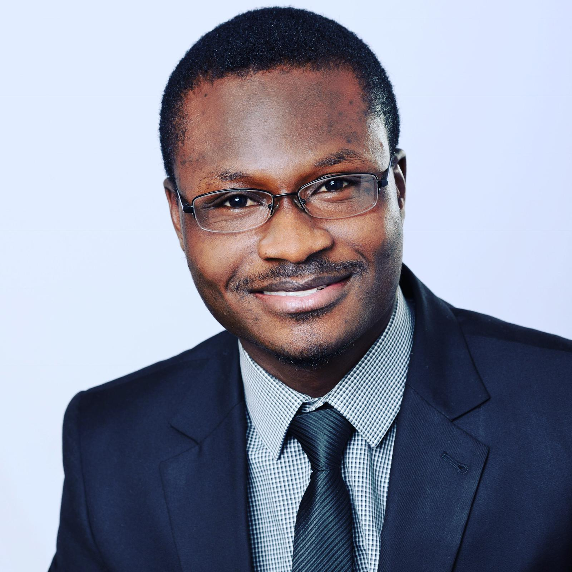
Arhin Acheampong (Afro-Sino Center for International Relations)
Arhin Acheampong is an International Development and Security expert with an MA degree in International Security from the Josef Korbel School of International Affairs, University of Denver. His specialization is in Intelligence, counter-terrorism strategies. He also has a certificate in Humanitarian Assistance with a focus on refugee populations in the Horn of Africa and the Middle East.
Arhin is passionate about global security and development and loves to write on emerging topics in these areas. In 2019, Arhin presented his paper on ‘The Scope of Insecurity in the Horn of Africa’ at an annual International Studies Association conference held in Accra, Ghana. Later that year, he conducted field research with ChildVoice International at the Imvepi Refugee Settlement in Uganda which hosts over seventy thousand refugees from South Sudan. He received a dual bachelor’s degree in Criminal Justice Administration (pre-law) and Global Studies at Michigan State University (MSU), with a minor in Peace and Justice Studies, and a concentration in International Development. During his time at MSU, he served as council representative for the Mastercard Foundation Scholars Program, representing the university and scholars at stakeholder meetings and conferences. He also served as the President of the African Students Leadership Association for two consecutive years. Arhin was later appointed to serve on the University’s board for the Year of Global Africa (2018).
In 2016, he was with the African Union Development Agency-NEPAD in Midrand, South Africa, working with the Communications Department. Among other things, he developed a database for all African missions in South Africa and all African Union (AU) missions in New York, Geneva, Washington, D.C. and Rome to facilitate communication among AU missions and the AU. As part of his political and social engagements, Arhin has participated in the Annual Model African Union Summit in Washington, D.C, the G20&G200 Summit in Germany, as well as conducted eye-screening and treatment exercises for community folks in the Northern Region of Ghana.
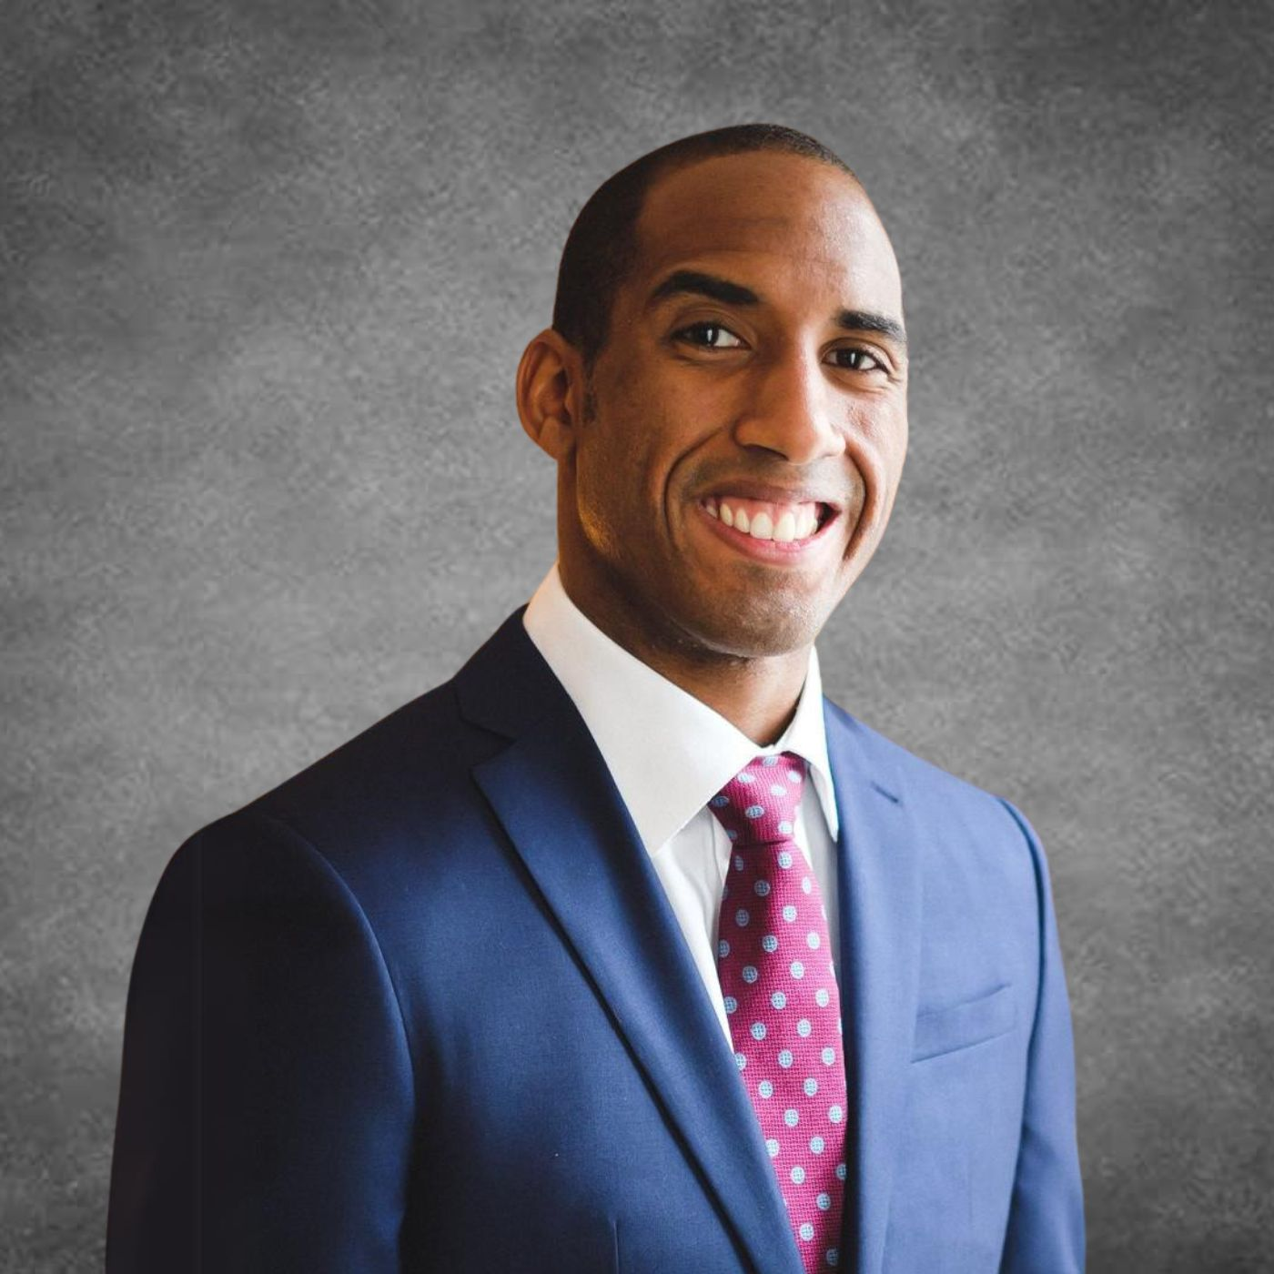
Leland Lazarus (Lazarus Consulting)
Leland Lazarus is the Founder and CEO of Lazarus Consulting LLC, advising companies and governments on navigating geopolitical risks around China’s engagement in the Western Hemisphere. He previously served as Associate Director of National Security at Florida International University’s Gordon Institute of Public Policy. At FIU, he taught U.S.-China relations and Chinese foreign policy, testified before Congress about China’s national security threats, spearheaded institutional partnerships with Taiwanese universities and CMA CGM–a global shipping company–and led the role out of an AI-powered dashboard tracking Chinese activities in the Western Hemisphere used by government officials, diplomats, and journalists.
From 2021 to 2022, Leland served as the Special Assistant and Speechwriter to two four-star Commanders of U.S. Southern Command (Department of Defense), where he advised on SOUTHCOM’s counter-China strategy. Leland was also a State Department diplomat in China and the Caribbean, representing U.S. interests overseas.
As Vice Chair of the Fulbright Association’s Board of Directors, Leland helps guide national programs that enhance international education and collaboration. He is a Council on Foreign Relations Term Member, a Member of the National Committee on US-China Relations Public Intellectuals Program, and a nonresident fellow at the Atlantic Council’s Global China Hub. His articles and commentary have appeared in NBC News, The Wall Street Journal, The Washington Post, Univision, Telemundo, The Miami Herald, Foreign Policy Magazine, and various international outlets.
Throughout his career, Leland has received recognitions such as being selected for the 2023 International Career Advancement Program and the 2022 Center for a New American Security Shawn Brimley Next Generation National Security Leaders Program. He also received awards such as the Defense Department Joint Civilian Service Commendation Award, and the State Department Distinguished Honor Award.
Fluent in both Mandarin and Spanish, He holds an M.A. in U.S.-China Foreign Policy at the Fletcher School of Law and Diplomacy, a B.A. in International Relations at Brown University, and Executive Certificates in Artificial Intelligence and Blockchain Technologies from the MIT Sloan School of Management.
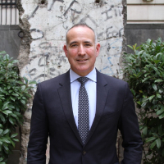
Jim Marckwardt (Johns Hopkins SAIS)
Dr. Marckwardt is a scholar-practitioner whose work bridges diplomacy, defense policy, and academic leadership. He serves as faculty co-lead for the Americas at Johns Hopkins SAIS, where he teaches graduate-level courses and directs the regional programming focused on the Western Hemisphere. He is also the founder and administrator of the SAIS Latin America Studies Initiative (LASI), a dynamic research community dedicated to advancing scholarly knowledge and fostering policy discussions on Latin America affairs. In 2024, he received the Johns Hopkins University Outstanding Recent Graduate Award in recognition of his contributions to scholarship and public service.
In addition to SAIS, he serves as faculty lead for Institutional Capacity Building at the Defense Security Cooperation University (DSCU), where he develops and delivers curriculum on defense governance and institutional reform for U.S. officials.
A retired U.S. Army Lieutenant Colonel and Foreign Area Officer, Dr. Marckwardt served for over 29 years in a range of policy and security cooperation positions. His prior roles include Country Director for Colombia and Venezuela at the Office of the Secretary of Defense for Policy; Defense Strategic Intelligence Planner for the Americas at the Defense Intelligence Agency; Political-Military Advisor and Liaison Office Director at the U.S. Embassy in Honduras for Joint Task Force–Bravo; and Senior Leader Engagement Officer for Mexico at U.S. Army North, where he worked closely with Mexico’s SEDENA. He is also a graduate of Argentina’s Escuela Superior de Guerra (Superior War School), where he studied strategic studies as an exchange officer.
Earlier in his career, he deployed twice in support of Operation Iraqi Freedom as an Armor Officer in command and staff roles. While in Iraq he co-authored a book The Defense of Jisr al-Doreaa, the premiere tactical primer on counterinsurgency for junior leaders. His research and writings have appeared in Joint Forces Quarterly, Small Wars Journal, and other outlets, focused on regional security, institutional reform, and military diplomacy.
Dr. Marckwardt earned his Doctor of International Affairs and Master of International Public Policy degrees at the Johns Hopkins SAIS, and earned a BA in International Business from Florida International University.
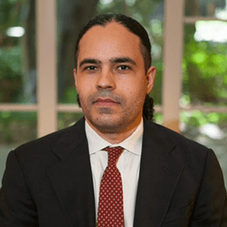
Reynaldo Ortiz-Minaya, Howard University
Born in the Dominican Republic, Reynaldo Ortíz-Minaya's areas of research reflect colonization's indelible impact on his land of birth and on surrounding islands in the Caribbean. His research includes world-historical structures of slavery (particularly in the Spanish-Caribbean); social regulatory processes; political economy; and ethno-racial labor formation. He examines the ways that systems of forced labor fluctuated and served as precursors to modern forms of penal punishment.
His forthcoming manuscript, "From Plantation to Prison: Visual Economies of Slave Resistance, Criminal Justice, and Penal Exile in the Spanish Caribbean, 1820-1886", explores the relationship between the expansion of slavery in Cuba and the rise of prisons in Puerto Rico as a means to incorporate the Spanish Caribbean into the world-market during the nineteenth century.
As a U.S. Fulbright Specialist, his additional research examines the historical relationship between forms of confinement (penal in particular) and the accumulation of profits under varying economic systems.
He serves on the board of directors for various international organizations focusing on penal reform and rule of law and has conducted research in Pakistan, Bulgaria, Hungary, Jamaica, South Africa, the Palestinian Territories, and throughout the Caribbean region.
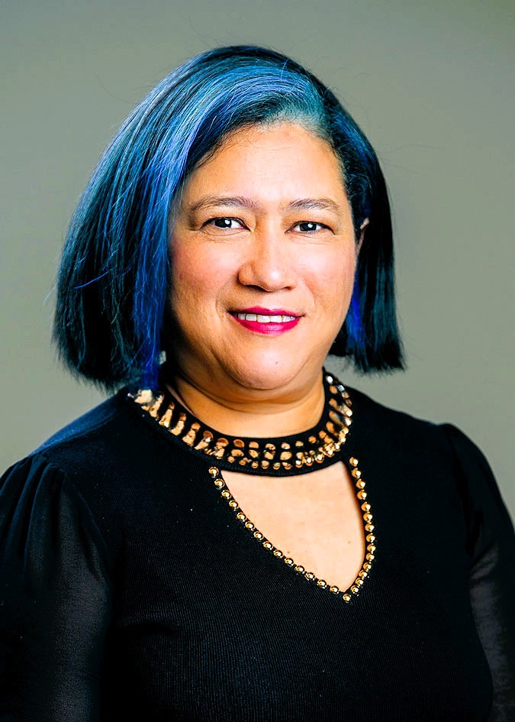
Iria Puyosa, Atlantic Council
Iria Puyosa is a senior research fellow at the Atlantic Council’s Democracy+Tech Initiative. She specializes in the complex interplay between technology and political dynamics.
For over a decade, Puyosa has investigated information operations that undermine democratic institutions and fuel political instability. Her work uncovers the multifaceted threats of digital authoritarianism and contributes to a deeper understanding of the challenges facing democracies in the digital age. Her research has exposed how Latin American authoritarian regimes use technology to silence dissent, surveil citizens, and control information flows.
Currently, Puyosa is focused on the tech policy environment in Sub-Saharan Africa. She is leading a project aiming to understand the region’s unique challenges and opportunities in navigating the digital age. By providing insights into the potential impacts of technology on development and human rights, her work contributes to developing effective and inclusive digital policies in the Global Majority countries.
Puyosa is also investigating emerging trends in the usage of technologies for repression, including digital surveillance, digital identity, and the deployment of data integration systems for population control.
Puyosa is also a member of the Toda Peace Institute’s International Research Advisory Council, where she advises on information warfare, social media and political conflicts, and conflict-sensitive approaches in social media platforms.
She actively participates in global Internet and tech governance processes, providing informed advice to policymakers and shaping strategies to counter
Information manipulation, limiting state surveillance, and protecting personal data through encrypted communications. Puyosa has highlighted the need for international cooperation and advocacy to protect human rights and promote digital freedom worldwide through her work.
Puyosa holds a PhD from the University of Michigan and a master’s in communication from the Andres Bello Catholic University in Venezuela. She was previously an associate professor at the College of Social Sciences at the Central University of Venezuela and a visiting professor at the Center of Latin American Studies at Brown University. Additionally, Puyosa chaired the Section on Venezuelan Studies in the Latin American Studies Association.
Throughout her career, Puyosa has authored numerous scholarly publications on information operations and digital authoritarianism, including “21st Century Authoritarianism in the Digital Sphere” and “Asymmetrical Information Warfare in the Venezuelan Contested Media Spaces.”


GEN John Wharton, Global Connective Center
General Wharton has served the Nation for more than three decades and has extensive experience in leadership, technology, acquisition, and logistics. He is currently a public and private sector advisor to numerous industries, universities, and governments. His focus is on technology acceleration in support of national priorities and homeland security. John also serves as Senior Advisor at The Chertoff Group and advises many U.S. Government Departments and Agencies.
In his last military assignment, General Wharton served as Commanding General of the United States Army Research, Development and Engineering Command (RDECOM) at Aberdeen Proving Ground, Maryland. There he led 13,800 scientists, engineers, and support personnel at more than 100 global locations controlling 75% of the Army’s R&D budget. While there, he won and led 5 of the 7 President of the United States (POTUS) National Manufacturing Innovative Institutes, a program to stimulate the nation’s economy by rapid technology development and transfer. He also ran the Science, Technology, Engineering Mathematics (STEM), the Army’s Educational Outreach Programs (AEOP), HBCU, Small Business Innovative Research (SBIR) and Technology Transfer (STTR) programs for the Army and had over 1,500 cooperative research and development agreements with universities and over 1,000 with industry.

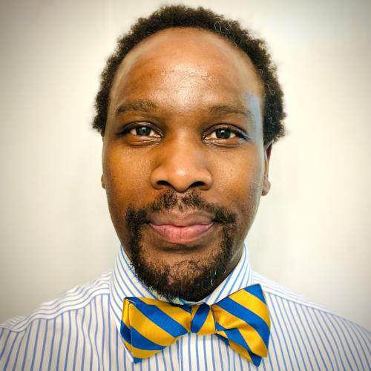
Phiwokuhle Mnyandu, Howard University
I grew up in the beautiful country of South Africa. Through my work at the Center for African Studies, as well as my my interdisciplinary research and teaching, I live my passion for student success and mentorship to produce the next generation who will attain a strong cultural competency on Africa, China, and the World. I am a sought-after analyst and speaker on US-China-Africa relations, having written the first book on South Africa-China relations by a single author (South Africa–China Relations: Between Aspiration and Reality in a New Global Order [2021]). I am also interested in the intersection of AI and African languages and cultures.

Bulelani Jili, Georgetown University
Dr. Bulelani Jili is an Assistant Professor at Georgetown University, Edmund A. Walsh School of Foreign Service, where he is part of the African Studies Program and an affiliate of the Science, Technology, and International Affairs (STIA) Program. His research interests include Africa-China relations, cybersecurity, ICT development, African political economy, internet policy, Chinese business law, law and development, and privacy law.
He is also a Faculty Associate at the Berkman Klein Center for Internet and Society, Harvard Law School. He is also a Visiting Fellow at Yale Law School, a Fellow at New America, an Advisory Board Member of the International Panel on Social Progress, a former committee member on the IEEE Standards Association's Global Initiative on AI Systems Ethics, a former Fellow at the Atlantic Council, a former Cybersecurity Fellow at the Belfer Center at Harvard University, and a former Electronic Privacy Information Center Scholar-in-Residence. He also conducted research for the China, Law, and Development project at Oxford University. The European Research Council funds the 5-year interdisciplinary and multi-sited research project, which seeks to comprehend the underlying order of China’s new globalism. He has also advised leading think tanks, governments, firms, and watchdogs such as the American Bar Association, OpenAI, the French government, Freedom House, the UK’s Foreign, Commonwealth & Development Office, the US State Department, the United Nations, and the Center for Strategic and International Studies.
His writing and work have appeared in leading think tanks and journals around the world, including African Affairs, Nature, Theory, Culture & Society, Mail & Guardian, Africa is a Country, The Elephant, South China Morning Post, African Centre for Strategic Studies, Politico, Lawfare, Tech Policy Press, The Economist, Financial Times, and East Asia Forum. He recently supported an amicus curiae brief before the U.S. Supreme Court (Thaler v. Perlmutter), engaging questions of authorship, creativity, and copyright in AI-generated works. He is also a regular panelist and speaker at international conferences, including those in South Africa, the Netherlands, South Korea, U.K., India, Switzerland, and Australia.
He is the recipient of numerous honors, including the Wenner-Gren Dissertation Fieldwork Fellowship, Berkman Klein Fellowship, Meta Research Ph.D. Fellowship, Google Public Policy Fellowship, International Strategy Forum award,Oppenheimer Graduate Fellowship Fund, and Orrick Fellowship.
Dr. Jili earned his Ph.D. from Harvard University. He also earned an M.Phil. from Cambridge University (UK), where he studied as a Standard Bank Africa Chairman’s Scholar. He received a Yenching Scholarship in 2016 to study at the Yenching Academy of Peking University (China), where he earned an M.A. in Economics. He took an A.B. with honors in Philosophy, Politics, and Economics (College of Social Studies) from Wesleyan University (CT), where he was a Pfeiffer Scholar.
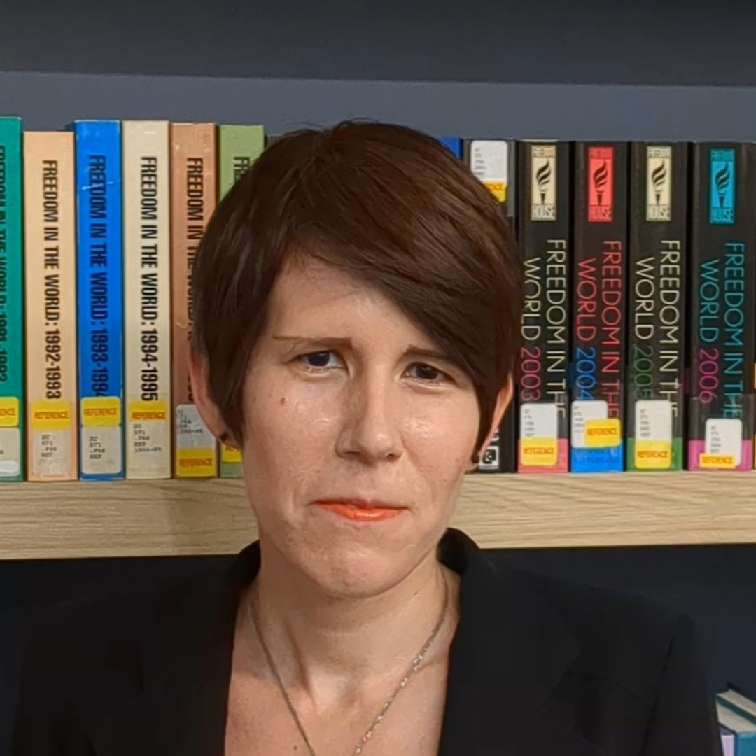
Beth Kerley, NED
Beth Kerley is a senior program officer with the National Endowment for Democracy’s International Forum for Democratic Studies. She is editor of and contributor to the Forum's series of publications on emerging technologies and democracy, including most recently Data-Centric Authoritarianism and Leveraging AI for Democracy. She was previously associate and online editor at the Journal of Democracy, and holds a PhD in History from Harvard University. The views expressed in this article are her own.
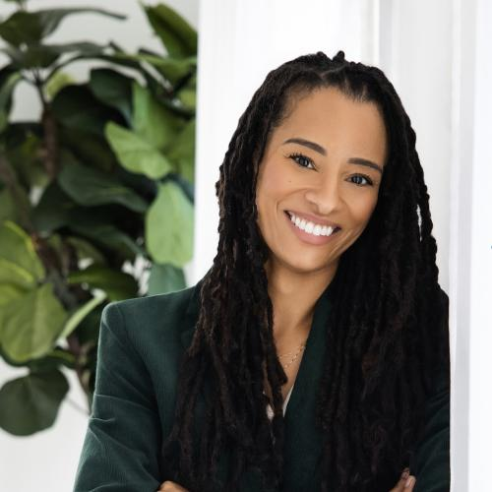
Dr. Anita Plummer, Howard University
Anita Plummer, Ph.D., is an associate professor of African Studies at Howard University. Currently, she is the Executive Director of the Center for Women, Gender, and Global Leadership. She is a co-convenor for the Africa-China Initiative’s Research Working Group titled “Demand, Disruption, and Transformation: African Agency in Digital Geopolitics.” Her research and teaching focus on African political economy, transnationalism, public diplomacy, and Sino-African relations. Before joining the faculty at Howard University, she taught International Studies at Spelman College in Atlanta, Georgia and she was also a Mellon post-doctoral fellow in the Cultures in Transnational Perspective Program and Visiting Assistant Professor of Global Studies and Political Science at the University of California Los Angeles. She was awarded a Carter G. Woodson Center Pre-doctoral fellowship at the University of Virginia, where she researched Mandarin language in Africa.
Her recent book Kenya’s Engagement with China: Discourse, Power, and Agency (Michigan State University Press, 2023) investigates the tension between official Kenyan and Chinese state narratives and individual Kenyans’ reactions to China’s presence to provide insight into how everyday Kenyans exercise their political agency and change. Her articles on China's engagements in Africa have been published in the National Political Science Review, the Journal of Asian and African Studies, Africa, the AfricaFocus Bulletin and Foreign Policy in Focus.
In addition to her work in academia, Anita has a passion for activism, community organizing, and international solidarity. She has co-coordinated seminars to South Africa, Namibia, and Mozambique with students, teachers, and activists to dialogue on issues ranging from state-sanctioned violence/police brutality, liberation movements and unfinished social justice agendas. She has served as a coordinating committee member of the U.S. Africa Network and volunteered with the American Friend's Service Committee. She was a past co-convenor of the African Studies Association's Women's Caucus. She currently serves on the board of the Environmental Investigation Agency.

